EXPERIMENT NO. 12
ROLE OF INFORMATION TECHNOLOGY IN ENVIRONMENTAL PROTECTION
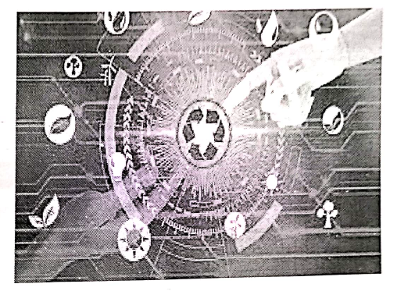
INTRODUCTION
In the 21st century, Information Technology (IT) has become a powerful tool in addressing global environmental challenges. From monitoring pollution levels to creating awareness and promoting sustainable practices, IT applications have played a crucial role in protecting the environment. The integration of technology with environmental management provides innovative solutions to reduce human impact on nature and promote sustainable development.
- Environmental Monitoring and Data Collection : Satellite imaging and Geographic Information Systems (GIS) are used to track deforestation, melting glaciers, and changes in land use. Remote sensors help monitor air and water quality in real time. Internet of Things (IoT) devices collect data on temperature, humidity, and pollution levels.
- Awareness and Education : Online platforms, social media, and e-learning portals spread awareness about climate change and sustainable lifestyles. Mobile applications provide eco-friendly tips and carbon footprint calculators.
- Decision-Making and Policy Support : Big data analytics help governments and organizations make informed environmental policies. Simulation models predict the impact of industrial projects on ecosystems.
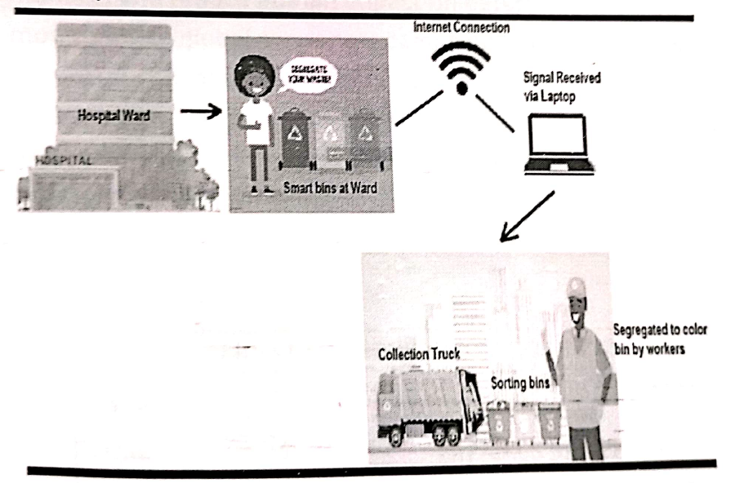
- Waste Management : IT-enabled smart bins and apps track waste collection. Digital platforms connect recycling companies with households.

- Energy Conservation : Smart grids and meters optimize electricity usage. IT promotes renewable energy through monitoring and management.
- Disaster Management : Early warning systems predict floods, tsunamis, and cyclones. GIS helps plan evacuation routes and rescue operations.
- Research and Development : Cloud computing and supercomputers assist scientists in climate modelling. Data sharing platforms support global sustainability projects.
CONCLUSION
Information Technology is a key enabler in environmental protection. By combining digital innovations with ecological strategies, IT has made it possible to monitor, manage, and reduce human impact on nature. From real-time monitoring to global awareness campaigns, IT continues to support sustainable development and environmental conservation. The future of environmental protection depends on how effectively IT solutions are integrated into daily practices and policymaking.
TERNA ENGINEERING COLLEGE, NERUL
TITLE | ROLE OF IT IN ENVIRONMENTAL PROTECTION
NAME | Avdhut Parish Madhavi
CLASS / BATCH | COMP / C2 / SEM III
ROLL NO. | 60
SIGN

